Camcorder and Zoom
- Use Laptop #1 (Zoom / Camcorder) and old Atem Mini
Connect micro HDMI to camcorder and larger HDMI to Atem Mini as usual
- Zoom settings
Audio… Microphone: Black Magic Design Speaker: Headphones
Video… Black Magic Design
- Activate mic 1 and camcorder sound on Atem: On / Off
- If using the Parish Hall Fender Amp, connected portable speakers, bluetooth mic...
Connect 15’ male to male 3.5mm audio cable to Fender amp’s phones output and Atem mic 1
- If not using Fender Amp use wifi mic located near the pulpit.
Use wifi mic receiver (to the left of soundboard on tech table).
Attach 1/8” to ¼” adapter to 15’ audio cable. Plug into wifi receiver and other end into Atem
- Connect black USB C (webcam out) to Atem. Plug other end of USB A (laptop) into hub

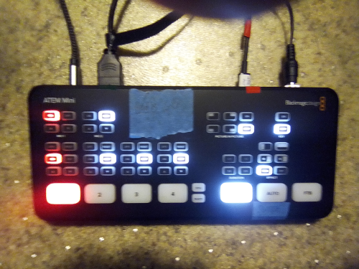

Cables from left to right
- mic 1: 15’ braided 3.5mm male to male audio (if using Fender amp)
or, mic 1: wifi mic dongle (not pictured) (if using wifi mic)
- HDMI cable from camcorder (as usual)
- black USB C into Atem webcam output… USB A into laptop.
- Power cable

